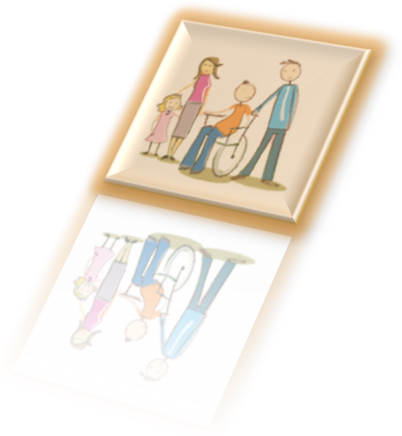



February 2017

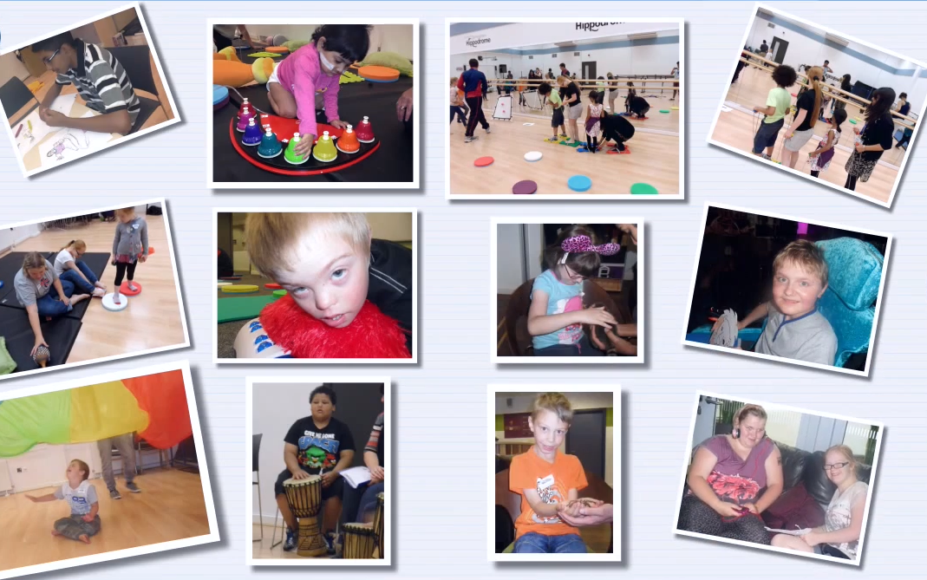

Short Breaks Walsall

Where possible please email expressions of interest forms to walsallfis@walsall.gov.uk


About Short Breaks in Walsall

Walsall Council is pleased to announce the programmes of Short Breaks taking place over the spring 2017 half-term holiday

Short Breaks can benefit the whole family. They provide opportunities for disabled children / young people to spend time away from their families, relax, develop new friendships, take part in new experiences and have fun doing positive activities. They also give families a break from their caring responsibilities, a chance to rest or spend time with their other children.

We recognise that all families are different and will need different levels of support and different types of Short Breaks; therefore we ensure that there are a wide range of Short Breaks to meet those needs.

We share the vision of Every Child Matters. We want young people to be healthy, safe, achieve, make a positive contribution, have supportive friends and families and benefit from economic well being.

A child or young person maybe able access a Short Break if they:
- Have a diagnosed disability
- Are aged 0 to 17 (until their 18th birthday)
- Live in Walsall.

This booklet contains details of when and where the activities are, who they are suitable for and an overview of what they involve.

Key:
Each activity is coded to show at a glance who it is aimed at:
ASD, Challenging Behaviour

Physical Disability, Complex Care Needs

Moderate Disability, Sensory

Important change
Expressions of interest will only be taken on the form submitted on line or on the form handed in to your child’s school. These must be received by Monday 23rd January 2017.

You will be notified of scheme allocation by email or letter w/c 6 February 2017 (please do not contact us before this date as we cannot give any information about allocation of places)

Thank you for using Walsall Council Short Breaks

How to express an interest in a Short Break

- Read the short breaks booklet and choose an activity provider that best meets your child’s age and particular needs and interests. Only one activity provider will be allocated for each young person.

- Complete the expressions of interest form with all your details and email to the Early Help hub- walsallfis@walsall.gov.uk, or hand in at your child’s school to SENCO staff by Monday 23rd January, 5pm. We will not be accepting expressions of interest over the phone unless you have a disability that prevents you completing the form.

- Make sure we have an up to date copy of your child’s short breaks passport as staff need to be able to provide the correct support to your child.

- Wait for an email from the short breaks team week commencing Monday 6th February that will inform you which provider your child has been allocated to. We will contact you if demand has been high and we are not able to offer a place.

- The activity club provider will then contact you offering a place with detail of what you need to provide for the activity.
Depending on demand most young people will only be allocated one session. We ask for a second choice of provider as requests for some clubs may be higher than others.

- Once you have been given an offer of a short break you must email or send a letter to the short break provider to confirm that your child will be attending the place by Monday 13th February.
If you do not do this the place will be offered to another young person.

If you have any queries about your child’s play scheme allocation, please contact the Family Information service on 01922 653383, or Short Breaks and Inclusion Team on ShortBreaks@walsall.gov.uk or 01922 650490.

Please remember expressions of interest should be made by email or completing the form at the back of this booklet and handing this in to your child’s SENCO staff. Requests should not be made over the phone unless you have a disability that prevents you completing the form.
Spring half-term 2017 – ‘At a glance’ guide:
Activity | Key | Ages  (years) | Times | Monday  20 February | Tuesday  21 February | Wednesday  22 February | Thursday  23 February | Friday  24 February
Progress  (New provider) |  | 5 -17 | 09.30 – 15.30 | TBC | TBC | TBC | TBC | TBC
Minions @ MyPlace |  | 8 – 12 | 09.30 – 15.30
SB @ MyPlace |  | 8 – 17 | 09.30 – 15.30
Resources for Autism |  | 5 – 17 | 10.00 – 15.00 |  |  |  | aged 5-8  years
Talking Hands * |  | 3 – 5 | 09.30 – 12.00
Urban Project |  | 8 – 17 | 09.30 – 15.30

Please take time to review the information regarding all our schemes on the following pages. It is your responsibility to identify schemes that are suitable for your child’s needs and interests.

* Talking Hands – please book directly with the Speech & Language Therapy Team. Details are on the following pages.

Important Information
Due to there being a very high demand of families accessing Short Breaks could you please ensure that if your child / young person is booked onto an activity but is unable to attend, that you contact the provider of the activity to make them aware as soon as possible. This will allow the place to be offered to another child / young person in need. Contact details for each activity will be contained in your notification email or letter.
If you have difficulty reaching the play scheme provider please contact the Short Breaks team on ShortBreaks@walsall.gov.uk or 01922 650490.

Minions@MyPlace (8 – 12 years)
ASD, Challenging Behaviour

Specialist Support Information:
Personal care (shower) • Manual Handling (hoist) • Administration of medication • One to one support

Dates: Monday 20th February
Time: 09.30 – 15.30
Venue: MyPlace, 60 Walstead Road West, Walsall, WS5 4PE

MyPlace (8 – 17 years)
Physical Disability, Complex Care Needs

Specialist Support Information:
Personal care (shower) • Manual handling (hoist) • Administration of medication • TDC • One to one support

Dates: Wednesday 22th February, Thursday 23th February and Friday 24th February 2017
Time: 09.30 – 15.30
Venue: MyPlace, 60 Walstead Road West, Walsall, WS5 4PE

Myplace is a youth centre that is accessible for wheelchair users and provides a safe and secure environment for young people. The holiday provision is managed by experienced youth service staff that are trained and have the competencies to provide support and care for young people with a wide range of needs including those with complex health care needs. This includes medical assistance, the monitoring and administering of diabetes injections, peg feeding and with all personal care needs. There are changing facilities including a shower, changing bed and an electric hoist.

Activities are offered on an individual needs basis with young people engaging in their choice of activity. All activities are designed to promote young people’s social skills and emotional well-being. They are adapted for all young people to engage in.

Myplace activities include:
- Arts and crafts
- Sensory room
- Adapted cycle bikes
- Outdoor sports
- Water and Sand play
- Gardening
- Games
- Computers
- Music room/DJ suite
- Baking/cooking

Young People will need to bring a packed lunch and a drink.

Progress (5 – 17 years)
Challenging behaviour
Physical Disability, Complex care needs
Moderate Disability, Sensory
Dates: to be confirmed
Venue: to be confirmed but likely to be in Brownhills
Time: 9.30 to 15.30
Specialist Support Information:
Personal care • Administration of medication
Progress is an experienced provider that specialises in supporting young people with wide ranging disabilities, with a focus on improving lives and helping young people be the best they can be. Groups are supported by employees, college students and volunteers with a good mix of skills in relation to support and range of activities. Provision includes a range of activities including-
- Arts and crafts
- Cooking and Baking
- Team games
- Sports
- Pool tables football tables
- Sensory activities
- Music
- Dance and films.
- Some days will include trips out, depending on what is going on in the local area and also the weather.
Young people will be provided with an activity plan for the day before they attend tailored to their needs, for example PEC symbols. Children aged 5 to 8 years will be supported in a separate group form the older young people.

Young people will need to bring a packed lunch and drinks.

Resources for Autism (8 – 17 years)
ASD, Challenging Behaviour

Physical Disability, Complex Care Needs

Specialist Support Information:
Personal care • Administration of medication • One to one support

Dates: Monday 20th February 2017 – Wednesday 22th February 2017
Time: 10.00 – 15.00
Venue: St. Luke’s Church, Selbourne Street, Chuckery, Walsall, WS1 2JN

Resources for Autism provide practical services for children and adults with an autistic spectrum condition and for their families and carers. All staff and volunteers are autism trained and services are designed to be welcoming and accepting of users whatever their level of need and support. For our Short Breaks holiday schemes we provide both indoor and outdoor activities which include:

Arts and crafts Team games
Cooking Sensory activities
Local trips out Creative arts (music, dance and drama)
Sports Den building and loose parts

Each session includes a breakfast club and where possible children are supported by the same buddy for each of the days they attend during that holiday.

A session with the same activities at the same venue will be offered for children who are aged 5 to 8. This will be just on Thursday 23rd February
If you express an interest in a play scheme place for your child with Resources for Autism and they have not accessed their services before, you also need to complete an online referral form. Please go to the Resources for Autism website and follow the link from the home page www.resourcesforautism.org.uk


Talking Hands (3 – 5 years)
ASD, Challenging Behaviour
Physical disability, complex care needs
Moderate disability, sensory


Dates: Monday 20th February 2017 – Thursday 23th February 2017
Times: 9.30 – 12.00
Venue: Shelfield Clinic, Coalheath Lane, Walsall, WS4 1PL

Developing early communication & Makaton signing skills through sensory experiences and play for children aged 3 to 5 years, with a range of special educational needs who have communication difficulties and would benefit from developing Makaton. Children stay at the sessions without their parents.

Please call the Speech & Language Therapy Team on 01922 605400 (option 3) to book places

Urban Project (8 – 17 years)
ASD, Challenging Behaviour
Physical Disability, Complex Care Needs

Specialist Support Available
Personal care • Manual handling (hoist) • Administration of medication • TDC • One to one support

Dates: Monday 20th February to Wednesday 22nd February 2017
Time: 09.30 – 15.30
Venue: Aldridge Airport, Bosty Lane, Aldridge, WS9 0QQ

Urban Project is based at Aldridge Airport which offers an exciting range of outdoor pursuits and indoor activities with full disability access including wheelchair users and specialist trained staff with over 25 years of experience. During the warmer months activities also include water sports at Sneyd Water Sports Centre and day trips. Activities include:

- Bushcraft | - Low Ropes
- Gladiator Challenge | - Cycling
- Orienteering | - Fan Descender
- Crate Challenge | - Abseiling
- Climbing Wall | - Zip Wire
- Archery | - Leap of Faith
- Circus Skills | - Land Yachting
- High All Aboard | - Rock Climbing
- Jacobs Ladder | - Crafts
- Bowling | - DVD’s
- Narrowboat Trips | - Video Games
- Canoeing | - Kayaking
- Raft Building | - Windsurfing
- Sailing | - Board Games

We welcome site visits if you are unsure. Contact Bob or Steve on 01922 744637.
Facebook – walsalloutdoorpursuits Twitter - @walsalloutdoorp www.walsall.gov.uk/outdoor_pursuits

Future Short Breaks
If you are having issues with receiving the Short Breaks information booklet in time for the expressions of interest period you can ensure that you get it as soon as it is released by registering your child/ren on the Walsall’s Children’s Disabilities Register, you must provide an email address. Please contact Walsall FIS to complete a Children’s Disability Register registration form. You can get in touch by calling 01922 653383 or emailing walsallfis@edu.walsall.gov.uk.
You can also download a form from www.mywalsall.org/fis.
Short Breaks Walsall

And don’t forget to follow us on Facebook to keep up-to-date on Short Breaks, and for other
sources of help and information
Short Breaks in Walsall:
Expression of Interest Form - February 2017

If you are interested in your child accessing a Short Break, please complete the details below and email to walsallfis@walsall.gov.uk.or give to your child’s school SENCO worker. If you have more than one child who you want to attend, please complete a form for each child. Please complete all sections and return by 23rd January

Whilst Walsall Council do everything that we can to ensure that your child can access the Short Break of your choice, due to the number of children accessing Short Breaks, this may not always be possible. For this reason we would ask that you make a 1st and a 2nd choice.
Parent / Carer Name
Parent / Carer Address
Parent / Carer Contact Number
Parent / Carer Email Address
Child’s Name
Child’s Date of birth
Child’s School
Does your child have an up to date Short Breaks Passport? We cannot accept a child without this information. | Yes | No
Preferred Activity
Start Date
End Date
Please specify of any days / dates / times that you would like or are unsuitable
Is your child’s short break passport up to date? We cannot offer a short break without this
2nd Choice Activity
Start Date
End Date
Please specify of any days / dates / times that you would like or are unsuitable
Is there anything else you would like to tell us?

