Year 10
Personal, Social, Health & Economic Education
Core Theme 1: Health and Well-being
Core theme 2: Relationships
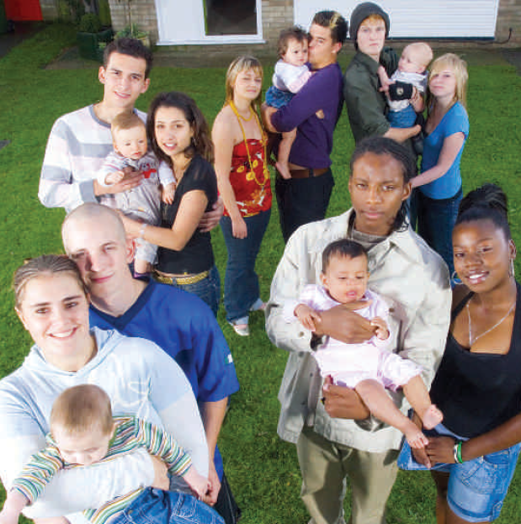

Teenage Pregnancy

We are learning about parenthood and the consequences of teenage pregnancy

We will be looking at:

- Parenting skills and qualities and their central importance to family life
- The consequences of unintended pregnancy and of teenage parenthood
- Abortion: The current legal position and the range of beliefs and opinions about it
- The pathways available in the event of unintended pregnancy, the possible physical and emotional reactions and responses people may have to each option and who to talk to for accurate, impartial advice and support

Name: Form:

Session 1: The Baby Borrowers - The Experiment

Students will:
- Familiarise themselves with The Baby Borrowers experiment
- Explore their own boundaries
- Understand that all our relationships affect everything we do
- Appreciate that ground rules are a useful tool in relationships
- Use their own imagination to consider other people’s experiences

Activity 1: After watching the clip…

What are the young people’s views on parenting at the beginning and at the end?

What are the parents’ views on lending their babies?

Who are the couples and what are they like?

What health and safety measures are in place?

Activity 2: Discussing the experiment

Questions for class discussion:

Is The Baby Borrowers experiment a good or bad idea? In what ways?

What do you think about lending babies to teenagers?

Would you like to take part in such a project?

Does this sort of series reach young people?

Do you think that this is a good way to learn about relationships and parenting?

What do you think the issues are for the babies, parents and young people involved?

Individual Reflection:

Write down three reasons why you would or would not take part in The Baby Borrowers

Activity 3: Coping with Friction & Difficulties

Watch the video:

Write down all of the issues that create friction and difficulties between the couples

Activity 4: Writing ground rules for the couples

How can we deal with some causes of friction between couples. What ground rules would you find helpful if you were moving in with someone?

Group activity: We are writing ground rules for (circle your couple)

Ava and Fisnik | Sam and Alex

Our ground rules:

Reflection

Are there unwritten ground rules in society, for example, queuing at a cash point machine?

Do you have (unwritten) ground rules in your family?

Do you use ground rules in your relationships, for example with friends or partners?

What sanctions are used if people break the agreements?

Session 2: What makes a good relationship?

Students will:
- Explore difference and the need for mutual respect and understanding
- Explore the nature of relationships in the light of the experiences

of The Baby Borrowers couples
- Experience approaches to problem solving and conflict resolution
- Explore and practise different forms of communication

Starter: Relationship relay race
- Split the class into two teams
- Each team has one large sheet of paper
- In turn each pupil should write down a different person they have a relationship with,
- The first team to finish is the winner

Activity 1: Team discussion:
What makes a good relationship? | What makes a relationship difficult?

How we can turn some of the negatives into positives? How can communication help?

In the Baby Borrowers:

What influences the way the couples behave?

Does our upbringing affect the way we behave in relationships?

What helps us understand another person?

Activity 2: Problem Page

Split into four groups. Each group should choose one letter asking for advice.

Write a response to the letter.

Share your problem and response with the class
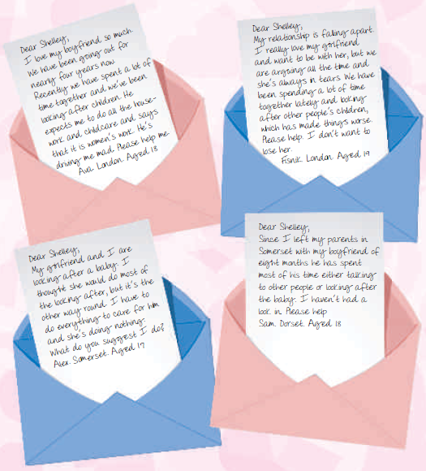

Activity 3: The Importance of Communication

Question for discussion: What is the difference between assertive, aggressive and passive behaviours?

Split into five groups
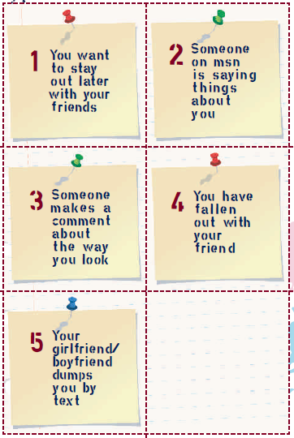

Each group will look at one relationship scenario.

In your groups choose two volunteers to act out the scenario in an assertive way, an aggressive way and a passive way.

The remainder of your group should observe.

Reflection: How did the different communication approaches change the situation?

Session 3: Parenting

Students will:
- Explore the reality of teenage parenting
- Think about the fun and enjoyment of parenting
- Consider what it means to be a parent
- Explore other people’s opinions on parenting
- Explore the concept of being a good parent

Activity 1: After watching the video

Split the class into two teams
- Give each team one large sheet of paper, divide each sheet into two columns – good and difficult
- Each pupil in turn should write down one good, and one difficult thing about having a baby
- Each pupil must add something different. The first team to finish is the winner

Good things about having a baby | Difficult things about having a baby

Reflection:

All of The Baby Borrowers couples were keen to become parents at the beginning of the experiment. Why do you think that the couples may have wanted a baby?

The Baby Borrowers couples’ attitudes changed by the end of the experiment. Why do you think that the couples’ attitudes changed?

Activity 2: Preparation for Parenting

Use words, phrases and images to record your ideas of ‘What makes a good parent’

Activity 3: What makes a happy & healthy baby?

Activity 4: Health & Safety Considerations

Write down all the health and safety issues you would consider when looking after a baby

Activity 5: Dear Baby Sitter…

You are the parents of a one year old baby. You are getting ready for a night out and you need to leave a letter for you baby sitter with instructions on how to look after your child

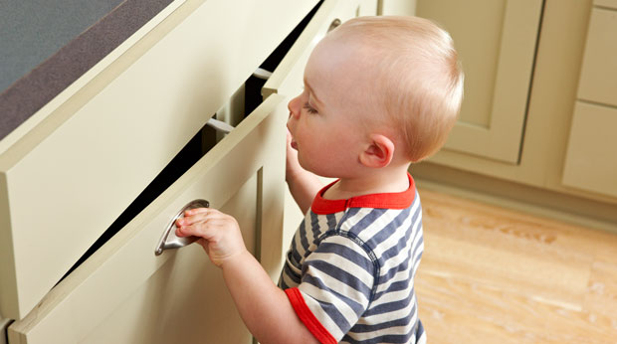

Reflection
- Present your letter to the remainder of the class.
- What have you realised about the level of care needed to ensure a baby’s health and happiness?

- What are the emotional needs of the baby and the parent/carer?

Session 4: The Carl & Kayleigh Story

Students will:
- Begin to be aware of the challenges posed by teenage pregnancy
- Begin to understand the responsibilities involved in having a sexual relationship
- Assess their knowledge of contraception

Activity 1: After watching the video write down as many forms of contraception as you can in two minutes

Activity 2: Carl and Kayleigh Quiz

1 How long have Carl and Kayleigh been together?

2 What meal does Carl make for Kayleigh?

3 What form of contraception are Carl and Kayleigh using?

4 What is the name of the baby that Carl and Kayleigh look after?

5 What pets arrived with the 5-11 year olds?

6 How old is Jack?

7 Six months after The Baby Borrowers experiment are Carl and Kayleigh still together?

Choose one of the following Carl and Kayleigh scenarios. In small groups discuss three ways to transform the situation in their scenarios and feedback to the class:

1 You are going to a party. Your friend is going to be there who you have had an argument with. You are not looking forward to it. How do you change the situation so you enjoy the party?

2 You are at home and really bored. Your friends can’t come over and you don’t know what to do. How do you change the situation so that you enjoy being on your own?

3 You want to go out with your friends, but you can’t as you have to go to a family celebration. How do you change the situation so you enjoy the family celebration?

Activity 3: Giving Advice

What should Carl and Kayleigh do?
Advice given | Good advice | Bad advice

Make a note of some of the classes suggestions. Do you think it is good or bad advice

Session 5: I think I’m pregnant, what do I do?

Starter: Where can a young person turn for advice?

Activity 1: Discuss the following options:
 | Pros | Cons

Friends

Parents

Teachers

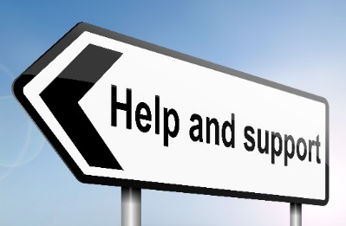
Activity 2: Other sources of help

There is also the option of seeking help online – this is obviously

more anonymous, but is also more impersonal

In groups: Look at the following websites and evaluate how effective you think they are in offering the help that a young person in this situation might need:
Website | Comment

www.pinkfridge.com/lal_pregnancy/teens.htm

https://www.brook.org.uk/?gclid=CMyTy6Hlv8kCFYW4Gwod9PcBVg

http://www.fpa.org.uk/help-and-advice/unplanned-pregnancy-abortion

Where could Shelfield students go for help?
Who can help? | Where can they be found?

Activity 3: Pregnancy options

Option 1: Being a teen parent

What might be some of the extra challenges and difficulties faced by teenage parents?

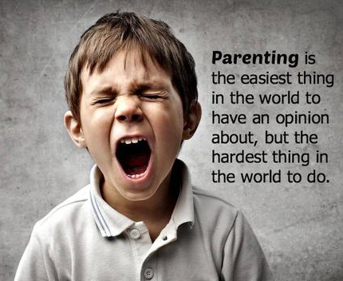
Do you think there are any benefits to becoming a parent when you’re still in your teenage years?

Option 2: Abortion?

After watching the Personal Story clip (slide 44) answer the following questions

How was Reannon affected by the abortion?

How has she coped with her decision to have an abortion?

Option 3 - Adoption

Open adoption and closed adoption

What are the positive and negative aspects of each type of adoption?
 | Positives | Negatives

Open adoption

Closed adoption

Test your knowledge about adoption

True or False?

In an open adoption the birth mother is able to have some form of contact with the child as he or she grows up

If the father’s name is on the birth certificate, he must give consent for the child to be adopted

Once the adoption is made legal it cannot be changed or reversed

In an open adoption the birth mother has some say in how the child is raised

An adoption is legal as soon as the new parents take the child

In a closed adoption the child has some contact with the birth mother

