ELMWOOD SCHOOL

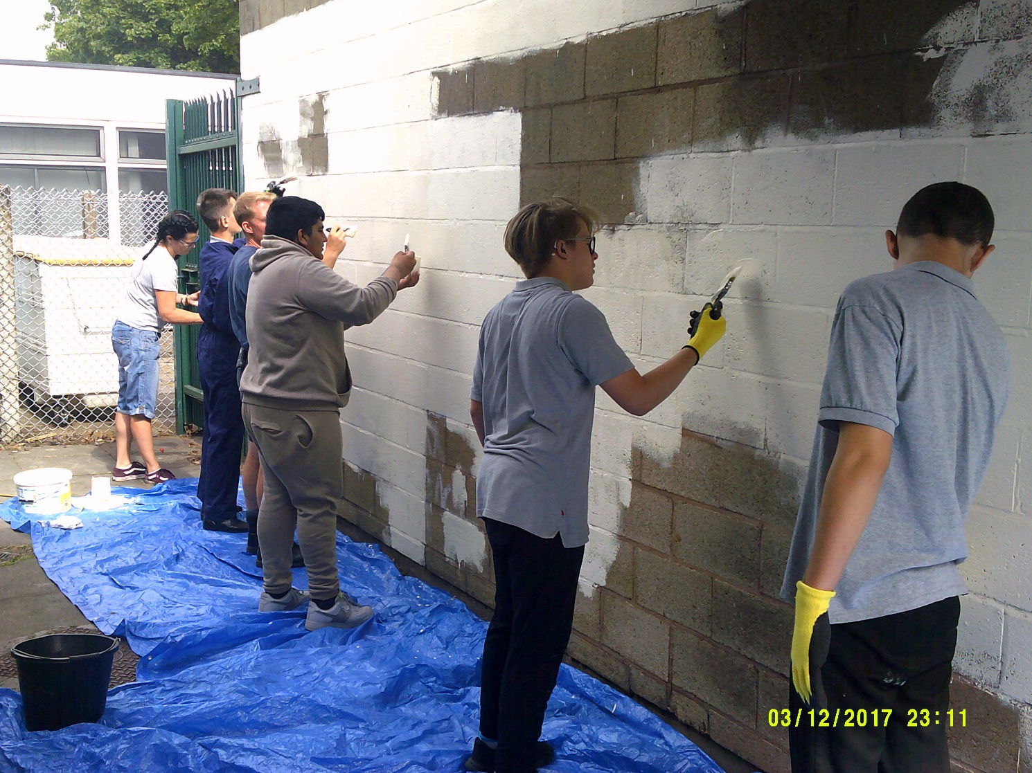
Grand Designs Day

PARENTAL HANDBOOK
Please complete and return any necessary forms asap

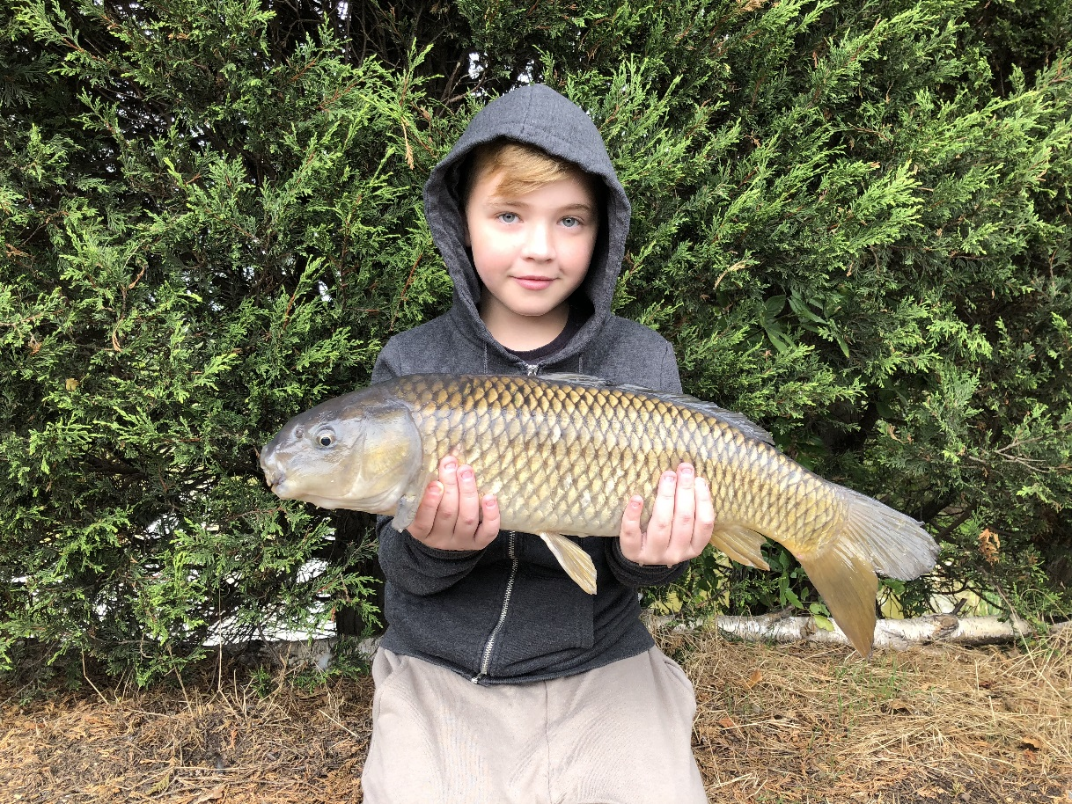
Pupil enjoying a Wider Key Skills lesson

WELCOME TO ELMWOOD SCHOOL
www.elmwood.walsall.sch.uk

A warm welcome ahead of your child commencing at Elmwood School.
It would be helpful if you can complete the following steps in this handbook and return to School for our records.
If you have any questions to ask, please do not hesitate to call on 01922 721081 or email postbox@elmwood.walsall.sch.uk and we will gladly help.
We hope your child soon settles into our community and is as successful as they can be.

KEY INFORMATION
What are our school times?
The school day starts at 8.40 am when pupils arrive for activities followed by breakfast before lessons begin. The day ends at 2.25 pm when transport arrives to take pupils home.
Food in School - Free school meals
If you are eligible for free school meals, an application form is available either from the School Office or via the School website under the Parents area.
How to pay for school meals
We buy into Walsall Council’s Catering Service and our Cook produces excellent meals which include a choice of a hot dinner, jacket potato or baguette as well as a choice of puddings, including healthy options of fruit/yoghurts.
Packed lunch
Packed lunches are provided for students when they are off site on either School trips or activities. Any child who is not eligible for a free school meal are welcome to bring their own food into School though we would request that consideration is given to the contents encouraging healthy eating.
Absence/Attendance

Regular attendance at school is fundamental to making sure that our pupils reach their full potential. As well as rewarding pupils each term for good attendance, the school carefully monitors this and sets high targets for the attendance of all pupils. Parents should always cover any absence with a phone call or note to school. Elmwood discourages holidays being taken during school time but where this is considered unavoidable and in exceptional circumstances, applications should be made to the Head Teacher well in advance, using a holiday request form.

In the summer term pupils are given the opportunity to attend Drayton Manor Park as a reward for achieving 100% attendance for either the previous summer term, autumn or spring terms. As agreed in conjunction with our School Council members, any pupil who is absent during the school day for any medical appointment or interview, but returns to School, are included within the 100% attendance figures. However, any other authorised absences such as attending a funeral, approved holiday requests etc do affect your child’s attendance and will therefore affect any overall attendance figures.

In addition to the above, all students termly who achieve 100% attendance receive a £5 gift voucher in recognition of this achievement.

Clubs
Elmwood has a School Football Team who represents the School both at away fixtures and at home.
A representative from each group sits on the Student Council and meet monthly with our Family Welfare Officers as well as being part of any interviews taking place in School.
We have a popular singing / drama club which occurs on Tuesday’s after school – due to limited transport it is appreciated if you can support collection for your child after this club.
Reasonable Force/Physical interventions - Team Teach

All Staff at Elmwood are Advanced Team, Teach trained and First Aid trained. Elmwood School uses Team Teach techniques to deescalate and if necessary physically intervene with pupils who present a threat to themselves or other pupils or staff or are damaging property. We comply with Government guidelines.

We will not accept any pupils on a non-contact basis. The school does not require parental consent to use physical force on their child. We will always inform a parent when it has been necessary to use physical interventions on their child.

Interviews by the Police
For information Police are free to approach and question any child who may have witnessed or been the victim of a crime, just as they can contact and interview an adult. Police can question a child without a parent present and are not required to obtain permission from a parent before questioning the child.
WORKING WITH PARENTS
Parental involvement
The School recognises the value of parental and community involvement and as such are included in their child’s journey through Elmwood as much as possible. This was highlighted with the Leading Parent Partnership Award that we received.
Newsletter
Newsletters are produced on a regular basis – usually monthly and distributed to pupils as well as being placed on the School website, Newsletters page.

MarvellousMe App
All parents and carers are encouraged to access the above app which enables parents and carers to share in their child’s school day. Celebrations can be shared as well as messages and photographs sent. When joining the School an invitation letter and personal code is issued enabling access to this site.
Coffee mornings
These are organised by our Family Welfare Officers and give parents and carers the opportunity to meet up for an informal chat and share any concerns.
Reports
Parents and Carers are updated on their child’s progress with progress reports that are sent out at the end of the Autumn, Spring and Summer terms. In addition, progress and achievement meetings are organised each term so that a review can take place and targets set for the coming term.
Annual Reviews/EHCP Meetings
Parents and Carers are invited to send their child’s annual review meeting/EHCP meeting (usually held on a Wednesday morning). An invitation and follow up letter are sent out two and six weeks before the scheduled date and will include a parental contribution form. When in Year 9 a transition review is held involving our Independent Careers Adviser as a child moves from Key Stage 3 to 4.
Parental Learning Days
Curriculum learning days are organised where parents and carers are invited to join in lessons with their child. These have included outdoor learning and food technology events, which have proved very popular.
Protecting Students
Legal drugs

Some of our pupils are prescribed medication for conditions that have been clinically diagnosed. Parents/carers have a duty of care to ensure that this medication is taken as per medical advice at all times. This includes during weekends and holidays. Parents/ carers also have a duty to ensure that medication is reordered in a timely fashion so that the pupil does not run out of medication. If a child arrives at school clearly unmedicated we reserve the right to contact parents/carers to come and collect them as there is a clear health and safety risk of them remaining at school. If it is not possible to collect, we will send them home in a taxi but we will be charging the costs to the parent/carer.

If you wish a review of your child’s medication then it must come through a medical practitioner; changing or stopping medication without such advice is a form of neglect. Under some circumstances the school is prepared to administer medication where it is not possible to do so at home. Please speak to our medical coordinator.

Illegal drugs/alcohol

If the school suspects* a pupil is under the influence of alcohol or illegal drugs we reserve the right to contact parents/carers to come and collect them as there is a clear health and safety risk of them remaining at school. If it is not possible to collect, we will send them home in a taxi but we will be charging the costs to the parent/carer. We will also make a referral to The Beacon – substance misuse professionals https://www.changegrowlive.org/the-beacon-walsall

*We will not be testing but will be looking for symptoms such as slurred speech, blurry eyes, uncoordinated movement and smell.

False alarm fire alarm activations

Any student who activates the School fire alarm system causing evacuation and disruption to learning will result in parents/carers being informed and a £10 fee requested to cover the cost of replacing the fire alarm box glass and for any call out fees.

Safeguarding
The safeguarding of our young people is of paramount importance to everyone who works at Elmwood School. All staff have received the necessary training and all visitors vetted on arrival. A copy of our Child Protection and Safeguarding Policy is available on our School website.
Policies
We have a wide range of policies available on our school website, policies page. We would recommend that parents/carers review these and in particular our Charging and Remissions Policy, and Freedom of Information Policy. A copy of our privacy statement is available on the parents and carers and parents’ letters and forms page.

Term dates
Elmwood School
School Holiday Dates – 2020/21
Open Close Days Open

Autumn Term 2020 Tues 1 Sept Fri 23 Oct 39
Mon 2 Nov Fri 18 Dec 35

Spring Term 2021 Mon 4 Jan Fri 12 Feb 30
Mon 22 Feb Thurs 1 April 29

Summer Term 2021 Mon 19 Apr Fri 28 May 29
Mon 7 June Wed 21 July 33
195
May Day Holiday – Monday 3rd May 2021
Training Days
Tuesday 1st September 2020
Wednesay 2nd September 2020
Thursday 1st April 2021
Monday 7th June 2021
Friday 16th July 2021
Health & Safety Days
Wednesday 16th December 2020
Thursday 17th December 2020
Friday 18th December 2020

Step 1 - Pupil Information Form (SIMS)

Basic
 | Surname |  |  |  |  |  |  |  | Forename
Middle Name (s) |  |  |  |  |  |  |  | Chosen Name
Gender |  |  | Date Of Birth
Pre-Admiss. Group |  |  |  |  |  |  | Proposed Admiss. Date

Background
Meal |  |  | F: free  M: school meal  S: Sandwiches | Dietary Needs |  |  | DAIR: no dairy produce  VEGA: vegetarian PORK: no pork COLR: Colour Allergy
Doctor/Surgery |  |  |  |  | Medical History
Religion
Ethnicity |  |  |  |  | Language

History
Previous School 1 | From | To | Reason for leaving
Previous School 2 From To Reason for leaving | From To Reason for leaving | To | Reason for leaving

Contact Details
Surname |  |  |  |  | Forename
Title |  | Gender
Day phone |  |  | Day place
Building
Number |  | Street
District
Town |  |  |  |  |  |  |  |  |  |  | County
Phone no. at this address
Post code
Relationship |  |  |  |  | Responsibility |  |  |  | Y/N
Court order | Y/N |  |  |  | Priority
CON: Contact Person. FOS: Foster Parent. GRD: Guardian. GRP: Grandparent. PAR: Parent. REL: Any Relative

Contact Details 2

Surname |  |  | Forename
Title |  | Gender
Day phone
Building
Number |  | Street
District
Town |  |  |  |  |  |  |  |  |  | County
Phone no. at this address
Post code
Relationship |  |  | Responsibility |  |  |  |  | Y/N
Court order | Y/N |  | Priority
CON: Contact Person. FOS: Foster Parent. GRD: Guardian. GRP: Grandparent. PAR: Parent. REL: Any Relative

Contact Details 3

Surname |  |  |  | Forename
Title |  | Gender
Day phone
Building
Number |  | Street
District
Town |  |  |  |  |  |  |  |  |  |  | County
Phone no. at this address
Post code
Relationship |  |  |  | Responsibility |  |  |  |  | Y/N
Court order | Y/N |  |  | Priority
CON: Contact Person. FOS: Foster Parent. GRD: Guardian. GRP: Grandparent. PAR: Parent. REL: Any Relative

Contact Details: Social Worker
Surname  Surname |  |  |  |  |  |  |  | Forename
Title |  | Gender
Building
Number |  | Street
District
Town
County |  |  |  |  |  |  |  |  | Phone no. at this address
Post code
Relationship | SOW |  | SOW: Social Worker

STEP 2 – PARENTAL AGREEMENT FOR ADMINSITERING TO ADMINISTER MEDICINE
The school/setting will not give your child medicine unless you complete and sign this form, and the school or setting has a policy that the staff can administer medicine.

Date for review to be initiated by
Elmwood School
Name of child
Date of birth
Group/class/form
Medical condition or illness
Medicine
Name/type of medicine
(as described on the container)
Expiry date
Dosage and method
Timing
Special precautions/other instructions
Are there any side effects that the school/setting needs to know about?
Self-administration – y/n
Procedures to take in an emergency
NB: Medicines must be in the original container as dispensed by the pharmacy

Contact Details
Name
Daytime telephone no.
Relationship to child
Address
I understand that I must deliver the medicine personally to | [agreed member of staff]

The above information is, to the best of my knowledge, accurate at the time of writing and I give consent to school/setting staff administering medicine in accordance with the school/setting policy. I will inform the school/setting immediately, in writing, if there is any change in dosage or frequency of the medication or if the medicine is stopped.

Signature(s) Date

Step 3 - Parents’/Carers’ Permission

I agree to (child’s name) ______________________ taking part in the activities described below:

Hill/Mountain walking in summer conditions Yes/No

Cycling (on or off road) Yes/No

Rock Climbing (indoors) Yes/No

Caving Yes/No

Orienteering Yes/No

Open Canoeing/Kayaking Yes/No

Sailing Yes/No

Camping in wild areas Yes/No

Swimming Yes/No

Swimming ability

- Is your child able to swim 50 metres? Yes/No
- Is your child confident in a pool? Yes/No
- Is your child confident in the sea or in open inland water? Yes/No
- Is your child aware of safety in water? Yes/No

Medical information about the young person

a) Does your child have any conditions that need medical treatment, including medication? Yes/No

If ‘Yes’ please give brief details ___________________________________________

- Please give details of any special dietary needs ___________________________
- Is your child allergic to any medication, food or other substance? Yes/No
If ‘Yes’ please give brief details ___________________________________________

- When did your child last have a tetanus injection? _________________________
- Is there any other information you think we should have to look after your child? ________________________________________________________________

NHS Medical No. ___________________________________

Contact details

Work phone number: ____________________________________

Home phone number: ____________________________________

Home address: ____________________________________

____________________________________
Other emergency contact:

Name: ____________________________________

Phone number: ____________________________________

Address: ____________________________________

____________________________________

Name of family doctor

Phone number: ____________________________________

Address: ____________________________________

Declaration

I agree to my child receiving medication as instructed and any emergency dental, medical or surgical treatment, including anaesthetic or blood transfusion, as considered necessary by the medical authorities. I understand the extent and limits of the insurance cover provided (available on request).
I understand that these activities will be led by a member of staff with relevant experience and qualifications.
I confirm that my child is in good health and I consider them fit enough to take part.
I will tell the school as soon as possible about any changes relating to medical or other circumstances as they occur.
I understand the need for my child to behave responsibly during travel to and from activities and also during the activity. I also recognise that if my child does not reach the expected standard of behaviour during offsite activities that it is at staff’s discretion that my child may be prevented from going on further activities.
I understand that the group leader will take this form or a copy on any offsite activity and that it may be given to a paramedic, a doctor or a mountain rescue team in an emergency to help my child’s rescue, treatment and recovery.

Your signature: ___________________________ Date: ___________________________

Your full name (IN CAPITALS): ________________________Pupil:____________________

Step 4 - ELMWOOD SCHOOL - Parental Consent

We are in the process of updating your child’s records and would be grateful if you could complete and return this form at your earliest convenience.

NAME OF PUPIL: ____________________________________

Activity | Please circle your preference below |  | Comments
Internet Access (with supervision) | Permission Given | Permission Refused
Photograph Student | Permission Given | Permission Refused
Include Student Photograph in School Newsletters | Permission Given | Permission Refused
Include Student Photograph on School TV Screens | Permission Given | Permission Refused
Pictures/videos shared with you on MarvellousMe | Permission Given | Permission Refused
Curriculum school Visits | Permission Given | Permission Refused
Data exchange with appropriate professionals | Permission Given | Permission Refused
Sex & Relationship Education (age appropriate) | Permission Given | Permission Refused

Signed: ______________________________(Parent/Carer) Date: ___________

STEP 5 - UNIFORM ORDER FORM

Pupil Name …………………………………………………………………

Carer/s Name/s …………………………………………………………..

Contact No. ………………………………………………………….………

Orders can also be placed directly on line with the supplier, A J Designs at http://www.a4jdesigns.co.uk/school-uniform-store/elmwood-school/
Grey Polo Shirt with school logo (£9 each)

Size | Youth  Medium | Youth Large | Youth  XL | Adult Small | Adult Medium | Adult  Large | Adult  XL
Quantity |  |  |  |  |  |  |  | Total  £
Black Sweatshirt with school logo (£13 each)
Size | Child’s  9-11  (140cm) | Child’s 12-13  (152cm) | Child’s  14-15  (164cm) | Adult Small | Adult Medium | Adult  Large | Adult  XL
Quantity |  |  |  |  |  |  |  | Total  £

Black Fleece with school logo (£16 each)

Size | Child’s  9-11  (140cm) | Child’s 12-13  (152cm) | Child’s  14-15  (164cm) | Adult Small | Adult Medium | Adult  Large | Adult  XL
Quantity |  |  |  |  |  |  |  | Total  £

TOTAL ORDER VALUE £………………………………

Please enclose payment with your order. Cheques should be made payable to Elmwood School. Thank-you.

For Office Use Only :

Date Received …………………………… Uniform Issued to ……………..……………….

Payment Received : Yes No Date of Issue ..………..……………………………
Step 6 - Elmwood School Student Acceptable Use Policy Agreement

I understand that I must use school systems in a responsible way, to ensure that there is no risk to my safety or to the safety and security of the systems and other users.

For my own personal safety:
- I understand that the school will monitor my use of the systems, devices and digital communications.
- I will keep my username and password safe and secure – I will not share it, nor will I try to use any other person’s username and password. I understand that I should not write down or store a password where it is possible that someone may steal it.
- I will be aware of “stranger danger”, when I am communicating on-line.
- I will not disclose or share personal information about myself or others when on-line (this could include names, addresses, email addresses, telephone numbers, age, gender, educational details, financial details etc)
- If I arrange to meet people off-line that I have communicated with on-line, I will do so in a public place and take an adult with me.
- I will immediately report any unpleasant or inappropriate material or messages or anything that makes me feel uncomfortable when I see it on-line by completing the E Safety yellow form.

I understand that everyone has equal rights to use technology as a resource and:
- I understand that the school systems and devices are primarily intended for educational use and that I will not use them for personal or recreational use unless I have permission.
- I will not try (unless I have permission) to make large downloads or uploads that might take up internet capacity and prevent other users from being able to carry out their work.
- I will not use the school systems or devices for on-line gaming, on-line gambling, internet shopping, file sharing, or video broadcasting (eg YouTube).
- I will act as I expect others to act toward me:
- I will respect others’ work and property and will not access, copy, remove or otherwise alter any other user’s files, without the owner’s knowledge and permission.
- I will be polite and responsible when I communicate with others, I will not use strong, aggressive or inappropriate language and I appreciate that others may have different opinions.
- I will not take or distribute images of anyone without their permission.

I recognise that the school has a responsibility to maintain the security and integrity of the technology it offers me and to ensure the smooth running of the school
- I will hand in my own personal devices (mobile phones) when requested by staff at the start of each day. I will get them back at the end of the day. Failure to hand in personal devices may result in them being confiscated and only returned to an appropriate adult. I understand that, if I do use my own devices in the school I will follow the rules set out in this agreement, in the same way as if I was using school equipment. USB and other portable data devices are not allowed on the school’s equipment
- I understand the risks and will not try to upload, download or access any materials which are illegal or inappropriate or may cause harm or distress to others, nor will I try to use any programmes or software that might allow me to bypass the filtering / security systems in place to prevent access to such materials.
- I will immediately report any damage or faults involving equipment or software, however this may have happened.
- I will not open any hyperlinks in emails or any attachments to emails, unless I know and trust the person / organisation who sent the email, or if I have any concerns about the validity of the email (due to the risk of the attachment containing viruses or other harmful programmes)
- I will not install or attempt to install or store programmes of any type on any school device, nor will I try to alter computer settings.

When using the internet for research or recreation, I recognise that:
- I should ensure that I have permission to use the original work of others in my own work
- Where work is protected by copyright, I will not try to download copies (including music and videos)
- When I am using the internet to find information, I should take care to check that the information that I access is accurate, as I understand that the work of others may not be truthful and may be a deliberate attempt to mislead me.

I understand that I am responsible for my actions, both in and out of school:
- I understand that the school also has the right to take action against me if I am involved in incidents of inappropriate behaviour, that are covered in this agreement, when I am out of school and where they involve my membership of the school community (examples would be cyber-bullying, use of images or personal information).
- I understand that if I fail to comply with this Acceptable Use Policy Agreement, I will be subject to disciplinary action. This may include loss of access to the school network / internet, detentions, fixed term exclusion, contact with parents and in the event of illegal activities involvement of the police.
Please complete the sections below to show that you have read, understood and agree to the rules included in the Acceptable Use Agreement. If you do not sign and return this agreement, access will not be granted to school systems and devices.

Elmwood Student Acceptable Use Agreement Form
Please complete the sections below to show that you have read, understood and agree to the rules included in the Acceptable Use Agreement. If you do not sign and return this agreement, access will not be granted to school systems. I have read and understand the above and agree to follow these guidelines when:
- I use the school systems and devices
- I bring my own devices in the school, e.g. mobile phones, gaming devices, cameras etc.
- I use my own equipment out of the school in a way that is related to me being a member of this school eg communicating with other members of the school via social media, accessing school website etc.
Name of Student / Pupil:
Group / Class:
Signed:
Date:

Step 7 - Boxing Training at Great Wyrley Amateur Boxing Club

Elmwood School has, over a number of years, had excellent links with the above club, using it to provide both taster/activity sessions and as a sport and skill progression route to gain ASDAN awards and qualifications. Boxing teaches self-control and discipline. The Club has also introduced some pupils to a new competitive sport which they have then continued with outside of school.
Whilst attending Elmwood your child may be given the opportunity to take part at sessions at the boxing club. Initial sessions will be non-contact and involve fitness and skills training. However, as they progress, pupils may be given the opportunity to improve through sparring. Whilst sparring, pupils will wear full head guards and gloves. Sparring will only take place under the control of an ABA coach.
Please complete the attached form to indicate your willingness for your child to participate in boxing training.
Are you happy for your child to attend boxing sessions? Yes / No

Are you happy for your child to take part in Sparring (if invited to do so)? Yes / No

Are there any medical issues which the school and boxing club need to be aware of? Yes / No
If yes, what are they? ________________________________________________________________________________________________________________________________________________________________________________________________________________________________________________________________________________________________________________________________________________________

Signed: ____________________________(Parent / Carer)

Name of Pupil: __________________________________

VISION STATEMENT
Elmwood School has embarked on a journey to be an outstanding provider of education services to some of Walsall’s most vulnerable young people .Elmwood School works at the heart of the Walsall community to support young people and their families to overcome the barriers that prevent them from becoming effective citizens. We provide an integrated caring service working with other agencies to identify the needs, uphold the rights and emphasise the responsibilities of young people who have special needs. Elmwood enables young people, who have not necessarily had a positive experience of education, to enjoy success and reach their potential in a small nurturing environment. We aim to set clear expectations and boundaries that allow pupils of all abilities equal opportunities to achieve their personal goals .Elmwood offers a personalised learning experience allowing young people to develop physically and mentally in a happy, calm, structured and supportive environment. Our differentiated curriculum is designed to engage the disaffected with a strong emphasis on Literacy, Numeracy and Physical fitness alongside a range of vocational qualifications underpinned with a commitment to Outdoor Education as a way of developing the whole child. We aim to offer a wide range of appropriate qualifications which enable every learner to access further education or employment. Elmwood values the unique nature of every individual student and is committed to them achieving their potential. We acknowledge the challenges facing those with Social and Emotional issues and a range of complex needs and are understanding and empathetic. However we have high expectations of success and believe that together as a community we can work though issues and develop independent life long learners with genuinely enhanced options of a healthy and productive life.

Elmwood School
King George Crescent
Rushall
Walsall
West Midlands
WS4 1EG

Telephone 01922 721081
As a school we feel that 95% of incidents can be resolved using de-escalation techniques to allow your child to reflect on their choices. However, when an incident occurs resulting in their being a risk or potential risk of harm to self; harm to others; damage to property and disrupting the learning environment of others we use BILD accredited techniques endorsed by Team Teach that enables staff to use positive handling options that are child centred. If your child has been involved in a positive handling encounter then you will be notified by staff by the end of the day highlighting the antecedents, how your child was handled and the outcome of that positive handling option.

HOME/SCHOOL
PARTNERSHIP

Elmwood School

Chartered for Excellence

The Home School Agreement is an important link between pupils, parents and school.

AS A SCHOOL WE ARE RESPONSIBLE FOR:
- Recognising and addressing the needs, rights and entitlements of each pupil.

- Supporting pupils to achieve their potential, providing them with regular feedback.

- Providing a safe, nurturing environment, which is well ordered and where learning can take place.

- Insisting on high standards in relation to Learning and Behaviour.

- Valuing the uniqueness of the individual. Praise achievements and efforts.

- Keeping parents informed about their child’s achievement, progress and areas of concern through effective communication.

- Including parents and carers in events and open days and encourage feedback.

- Providing opportunities for curriculum enrichment, accreditation and extension activities where appropriate. Preparing pupils for the independent journey of lifelong learning.

Signed: ………………………………………………Class Teacher
Date: …………………………………………………

AS THE PARENT I AM
RESPONSIBLE FOR:

- Supporting the School in relation to the vision.

- Ensuring pupils attend School, punctually, prepared for work and in school uniform.

- Providing a formal explanation if my child is absent.

- Attending Pupil Review meetings and contributing appropriately within them.

- Keeping the school informed about any concerns through an effective communication system with School.

- Supporting my child in opportunities for home learning.

- Supporting the Schools approach to curriculum, accreditation and enrichment activities.

- Supporting the Schools approach towards Behaviour Management and approaches.

- Ensuring that my child takes any necessary medication at home and provide School with sufficient for their use.
Signed: ……………………………………………… Parent/Guardian
Date: …………………………………………………

AS THE PUPIL I AM
RESPONSIBLE FOR:

- Trying my best and working hard.

- Following the Schools 5 basic expectations.

- Attending School on time and be ready and prepared to work.

- Wearing the school uniform, with pride.

- Working to a standard that stretches and challenges me.

- Take part in activities inside and outside of the classroom.

- Participating in group discussion to enable me to reflect on my choices.

Signed: ………………………………………………Pupil
Date: …………………………………………………
Request for Holiday during School Term Time

To: The Headteacher

Authorised absence for an annual holiday is requested for :-

Name of Pupil …………………………………………………..…………………………………

Dates: From ……………………… to ………………………………….

Reason for asking for absence during school time :
……………………………………………………………………………………………………
……………………………………………………………………………………………………

Signed ……………………………… Dated ………………...........
Permission for a leave of absence will not be granted, unless there are exceptional circumstances.

In the event that a child is taken out of school for holidays, a fine of £60 per child will be imposed, which must be paid within 21 days. Failure to pay will increase the fine to £120 per child, which must then be paid within 28 days, to avoid potential prosecution.

To be completed by Headteacher

To: ………………………………………………………………………… (Parent/Guardian)

You have proved that there are exception circumstances for this request and, therefore, your request is approved and the absence, as set out above, is duly authorised
OR
You have failed to prove that there are exceptional circumstances and request is not approved.
Therefore, if the pupil is absent as proposed above, it will be recorded as unauthorised

SIGNED : ……..……………………………… DATED: …………………

Nb. Any absence of two weeks in any one year is the equivalent of a half a day each fortnight. PLEASE consider the effect on your child’s education of holidays taken in term-time.

