Dream Design Maths Challenge

Task 1:
You have a maximum of 20 minutes and a budget of £2150 to research what you would like in your dream bedroom.
- Create a an image of your perfect bedroom
You can have anything in your room but you MUST include the following:
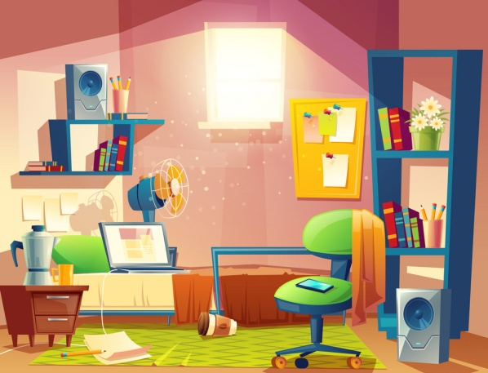
Bed
Wardrobe
Drawers
Desk
Lamp

- Create a spreadsheet for your design project
Item | Cost (£) | Total (cumulative)
Bed | 349.99 | 349.99
Wardrobe | 169.99 | 519.98
E.g.

Task 2:
- List the price of your items in ascending order.
- What percentage (%) of the budget have you spent on furniture?
- Extension: Convert the answer to a decimal (3 d.p)
- What fraction of the budget have you spent on the bed?
Extension: Show the answer as a percentage (%)

- The wardrobe is in a flash sale and has been discounted by 7%. How much does it cost now?
- If you had £273 in your bank account at the start, how much will you be overdrawn when you finish your room?
- Your Budget has been increased by 17%. How much can you spend now?

How would you spend the extra money? Explain your answer.

