Out & About Project.
Nailed it!
Hi,
With Valentine’s on the way it would be great to make something for a loved one. Something hand-made means you have taken the time to build something for a loved person.
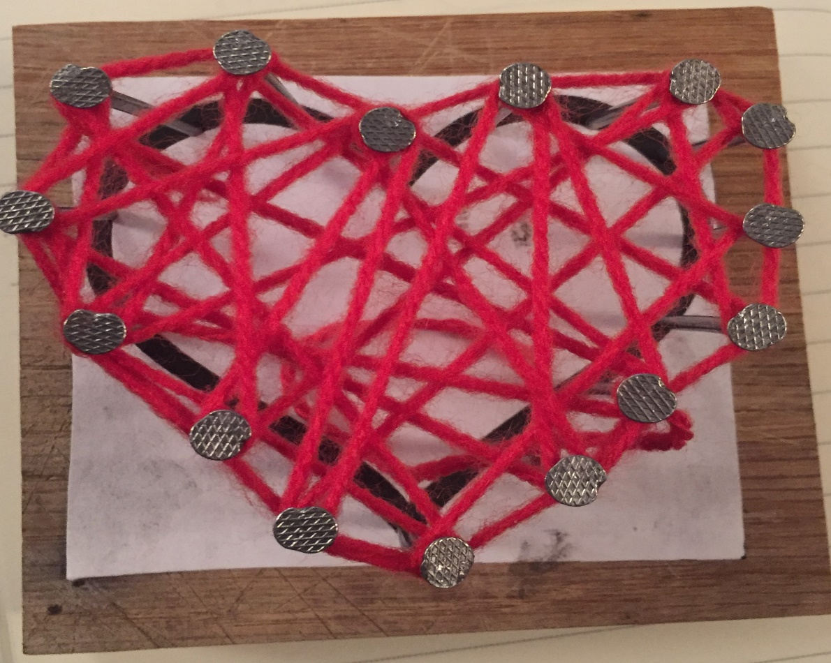

All the materials are provided.
Using the skills you already have from making previous nail art and poppy.
Place the paper template onto the wood, nail around the outline then use the red wool to ‘colour’ in your heart.

Stay safe & enjoy!
Mr. Whittaker

